<https://github.com/itc-wgtools/cPP-Tools>

Contents

**Branches** 2

What are they? 2

**Pull Requests** 2

What are they? 2

Review a Pull Request 3

Permalink (Reference Link) – How to manually generate from browser 4

File an Issue 5

Comment Directly on Changes 5

## **Branches**

### What are they?

<https://help.github.com/en/articles/about-branches>  
<https://help.github.com/en/articles/github-glossary#branch>  
<https://git-scm.com/book/en/v2/Git-Branching-Branches-in-a-Nutshell>

*In short:* It is a copy of the main code/document which you can make changes in.

In this way you can have the changes not affect the original, thus preserving the “working version”, and review such changes among your peers before choosing to or not to commit/merge/add those changes to the new main or working version.

* Parallel version of a repository
* Used to isolate development work without affecting other branches in the repository.
* Each repository has one default branch, and can have multiple other branches.
* You can merge a branch into another branch using a pull request.

## **Pull Requests**

### What are they?

<https://help.github.com/en/articles/about-pull-requests>

*In short:* It is a request to ask other users/members to “pull” your changes or your version of the repository into theirs, as such a pull request. When someone makes a pull request, they are asking to add changes to the main or working version of the code or document.

* Let’s you tell others about changes you've pushed to a branch
* Once a pull request is opened, you can discuss and review the potential changes
* Choose to merge changes into the base branch or even request the changes be modified.

### Review a Pull Request

**Pull Requests > Add your review > Review Changes**   
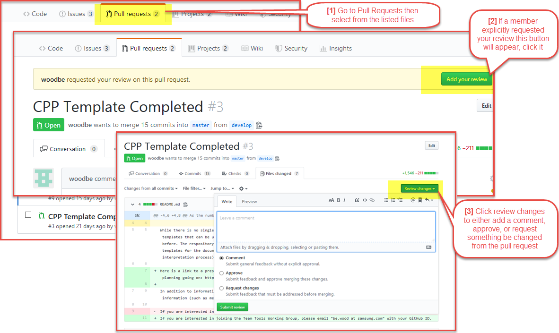  
Alternatively you can “Start a review” on individual lines by hovering with your mouse to the right of the line number till a “+” sign appears. Clicking on the “+” icon which appears will allow you to add a comment or start a review. A review is a more formal way to ask members to give more scrutiny to the item or issue at hand.

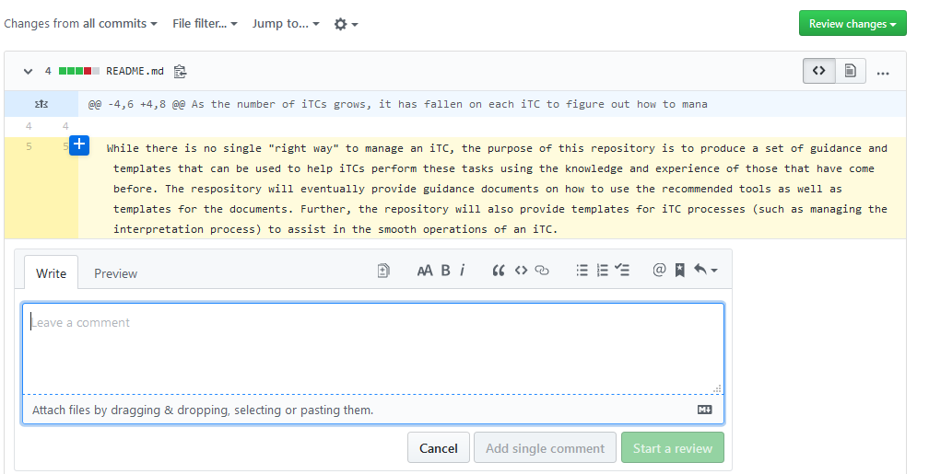

### Permalink (Reference Link) – How to manually generate from browser

**Pull Requests > Files Changed > Code/File Options [“…”] > View File > Blame > Click a Line > Copy URL**

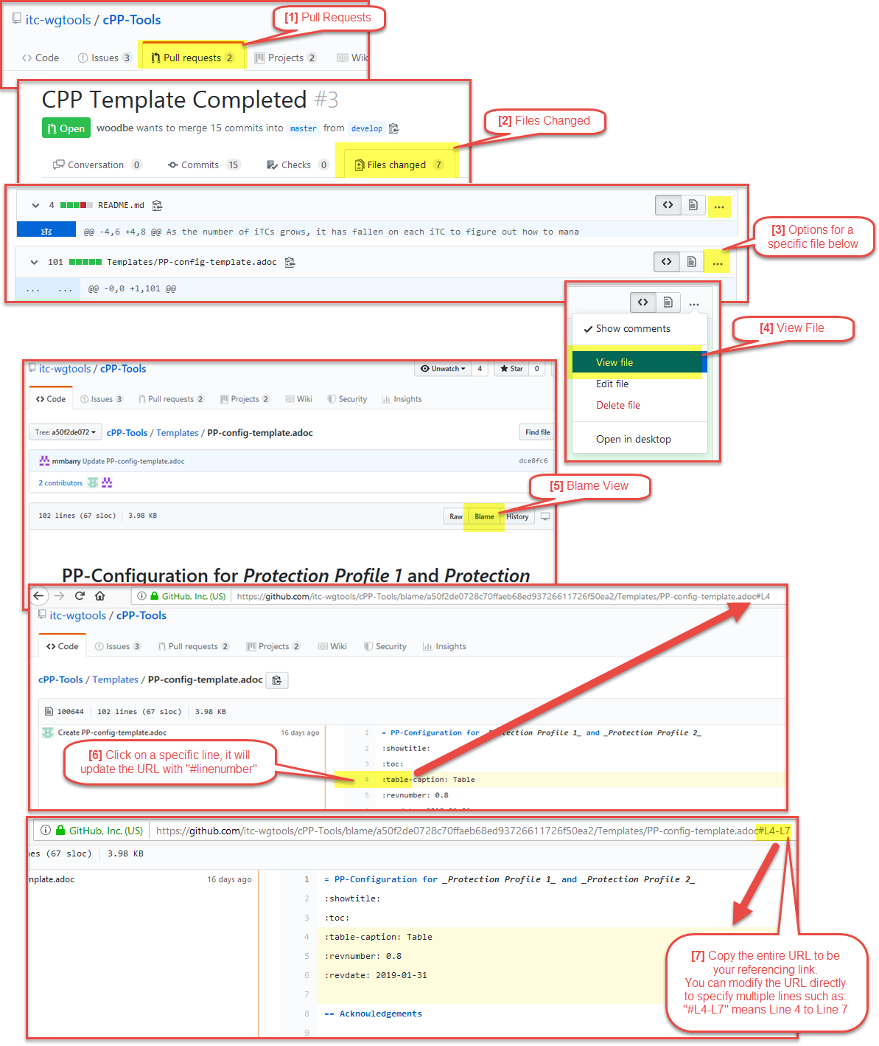

### File an Issue

**Issues > New Issue > Write Comment + Permalink**

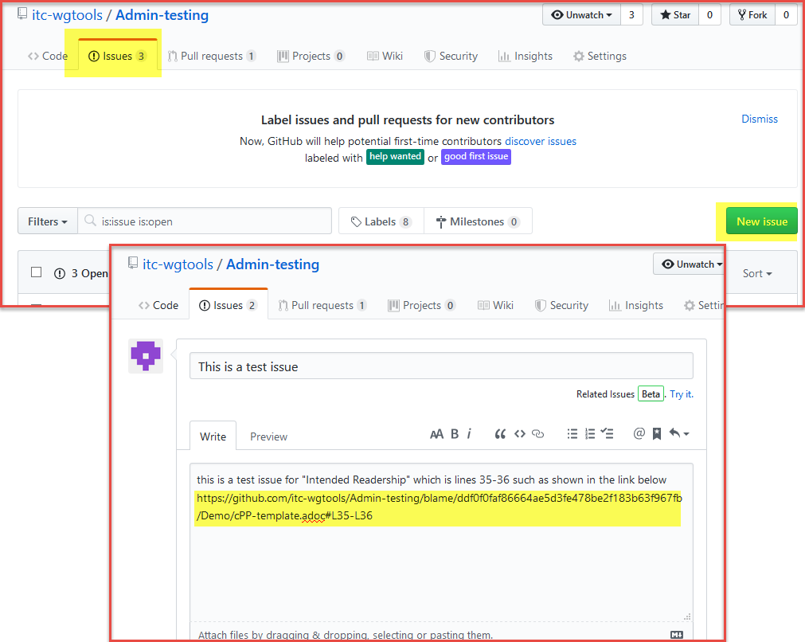

Comment Directly on Changes  
**Pull Requests > Select Code/File Below > Files Changed > Hover Next to line, click on “+”**  
You can comment on individual lines by hovering with your mouse to the right of the line number till a “+” sign appears. Clicking on the “+” icon which appears will allow you to add a comment or start a review. A review is a more formal way to ask members to give more scrutiny to the item or issue at hand.  
